9Classes and object
__________________________________________
Q. What is class?
class is combination of state and behavior Here we can say state means variable declared within class and behavior means function define within class
or
Class is combination of instance variable, class variable, method, instance initializer, static initializer, constructor and nested classes
Instance variable: if we declare any variable within class without static keyword called as instance variable.
class variable: if we declare any variable within class with static keyword called as class variable.
Instance initializer: instance initializer means if we define block within class without static keyword called as instance initializer.
method: if we define function within class called as method.
static initializer: static initializer means if we define block within class with static keyword called as static initializer.
Constructor: constructor is a function same name as class name but without return type.
Nested class: Nested class means class within class called as nested class.

How to declare class in JAVA
_________________________________________
Syntax of class declaration in JAVA
access specifier class classname
{ access specifier datatype variablename;
access specifier return type functionname(datatype variablename)
{
}
}
Example:
class Employee
{ private int id;
private String name;
private long sal;
void addNewEmployee(String n,int I,int s){
name=n;
id=i;
sal=s;
}
}
Example with source code
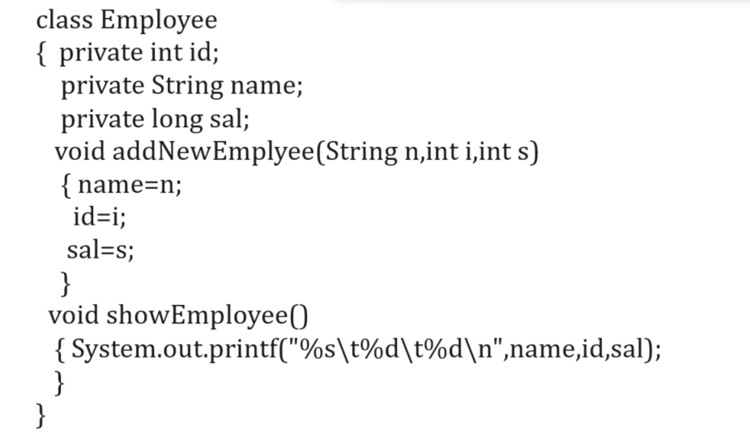
If we think about above class, we have private keyword
private is access specifier in Java
Q. What is access specifier?
Access specifier are the some keywords which is used for apply restrictions on class and its member.
There are four types of access specifier in JAVA
1. private: private access specifier means member cannot access outside of class as well as outside of package.
2. public: public access specifier means member can access outside of class within package as well as outside of package.
3. protected: member can access within child class within same package or outside of package.
4. default: default means member can access outside of class but within same package.
Q. Why use class or what is benefit of class?
____________________________________________
There are three benefits of class
1. Ability to store different type of data
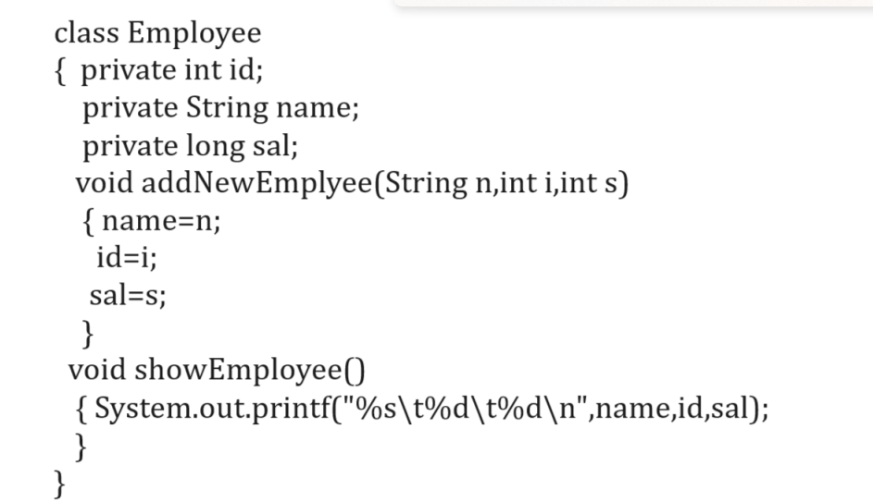
if we think about above class, we have three types of data in it, id has type of integer, name is type of string and sal is type of long means we can say it contain different type of data.
So, this is major reason people say class is user define data type or it is complex data structure
2. Provide Reusability of code
_________________________________________
Means we can declare class only once and we can reuse it more than one time it is called as reusability
How can we reuse class more than one time?
_______________________________________________
If we want to reuse class more than one time we required to create its object.
Q. What is object?
______________________________________________
Object is run time entity or object is instance of class or
Object is a photo copy of class or object is block of memory where class data store.
How to create object in JAVA
________________________________________________
If we want to create object in java, we have to use following syntax
Syntax: classname ref= new classname();
Example: Employee emp = new Employee();
Here emp is reference of Employee class and new Employee() is actual object.
Q. what is difference between reference and object?
____________________________________________________
Reference is variable which hold address of objects and object is block of memory where class data store shown in following diagram
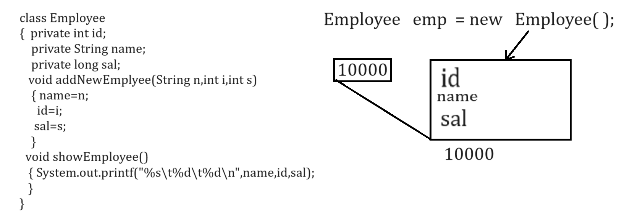
Q. Why use reference with object?
_____________________________________________
Q. What happen if we not use reference with object?
Before discussing this question, we will discuss how to use user define class in java or steps to use class in java
Steps to use class in JAVA
A. declare class
class Add {
}
B. Define function within class
class Add //step1
{ int a,b;
void setValue(int x,int y) //step2
{ a=x;
b=y;
}
void showAdd()
{ System.out.printf("Addition is %d\n",a+b);
}
}
C. Create Object of class
______________________________________
class Add //step1
{ int a,b;
void setValue(int x,int y) //step2
{ a=x;
b=y;
}
void showAdd()
{ System.out.printf("Addition is %d\n",a+b);
}
}
public class AddApp
{ public static void main(String x[])
{ Add ad = new Add();//step3- create object
}
}
d. Call its member using object.membername
Complete source code with example
class Add //step1
{ int a,b;
void setValue(int x,int y) //step2
{ a=x;
b=y;
}
void showAdd()
{ System.out.printf("Addition is %d\n",a+b);
}
}
public class AddApp
{ public static void main(String x[])
{ Add ad = new Add();//step3- create object
ad.setValue(10,20);
ad.showAdd();
}
}
Following diagram shows working of above code.
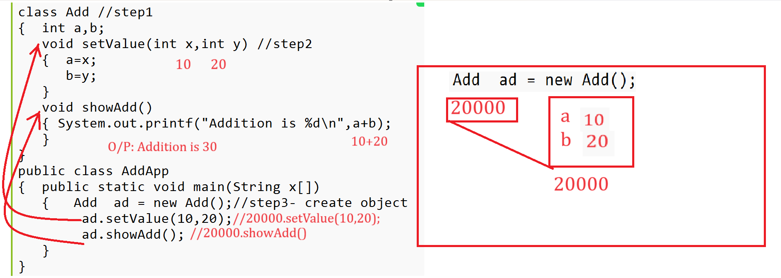

Example: WAP to create class name as Square with two functions
void setValue(int x): this function accept integer as parameter
void showSquare(): this function can calculate square and display it.

Assignments
Q. WAP to create class name as Circle with two methods
void setRadius(float radius): this method help us to accept radius as parameter
void calArea(): this method can calculate area of circle and display it.

Q. WAP to create class name as Table with two methods
void setNum(int no): this method can accept number as parameter
void showTable(): this method can calculate table of number and display it
Q. WAP to create class name as Power with two functions
void setValue(int base,int index): this method can accept base and index value
void calPower(): this method can calculate power of number and display it.

Q. WAP to create class name as Perfect with two functions
void setNum(int no): this function accept number as parameter
void calPer(): this method can check number is perfect or not

Q. WAP to create class name as Factorial with two functions
void setValue(int no): this function can accept number as parameter
void calFactorial(): this function can calculate factorial of number and display it.
Q. Why use reference with object?
or
What is benefit of reference?
_______________________________________________
reference is use for when we want to reuse same object more than one time.
Q. What happen if we not use reference with object?
_______________________________________________
if we do not use reference with object then object known as anonymous object and in this case JVM create new object every time means we have new block every time in memory so we get new content means if we not use reference with object then we cannot use same object more than one time.
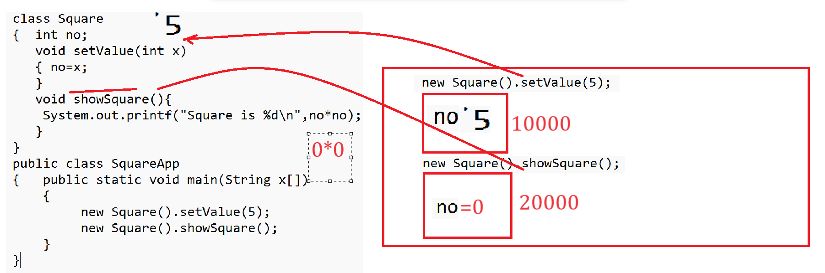
if we think about this diagram then we have main function and in main function we have statement
new Square().setValue(5) means we have block of memory whose address is 10000 and we pass 5 value on it and we have one more statement name as new Square().showSquare() means we have again new object in memory whose address is 20000 and we call showSquare() function by object using object address is 20000 but in 20000 address there is no value for no so we get answer Square is 0
so we want to get proper answer square is 25 then we required to use object whose address is 10000 with setValue() function and with showSquare() function then we can store its address in variable of Square class and use object by using that variable and class variable known as reference shown in following diagram
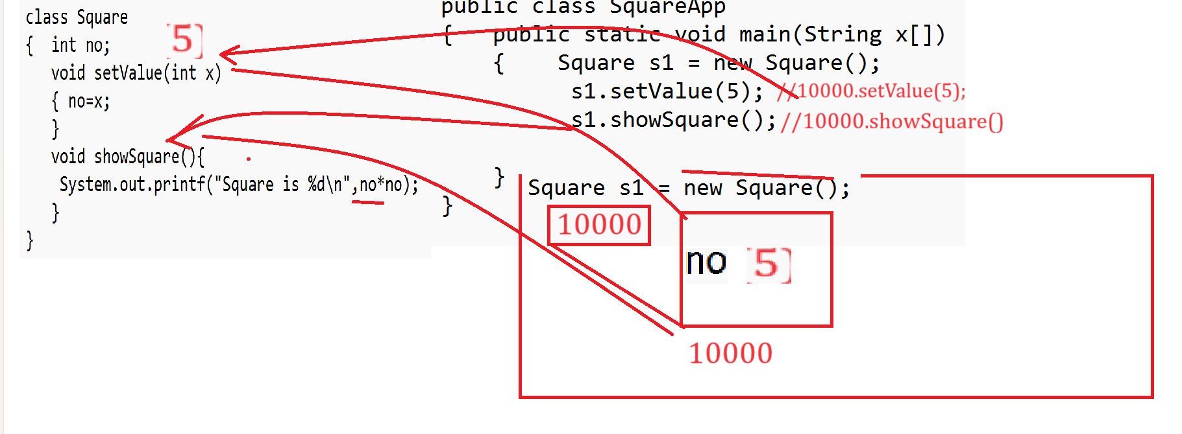
if we think about above code we have statement in main method Square s1 = new Square(); here we object name as new Square() whose address is 10000 and we store this address in s1 reference and we have statement s1.setValue(5) means 10000.setValue(5) means we call this function by object whose address is 10000 means 5 value get stored in object whose address is 10000 and again we have statement s1.showSquare() means 10000.showSquare() means here at the time of showSquare() calling we not create new object just we are using previous created object by using address or reference means here we showSquare() contain no*no which access from 10000 location means we use same object two times with the help of reference so we can say reference is used for use same object more than one time.

Q. Can use more than one reference with single object?
__________________________________________________
Yes, we can use more than one reference with single object means we can share the address of single object with multiple class variable or reference
Note: But there is possibility if we change object content by using any one reference then objects previous data may be loss shown in following code.
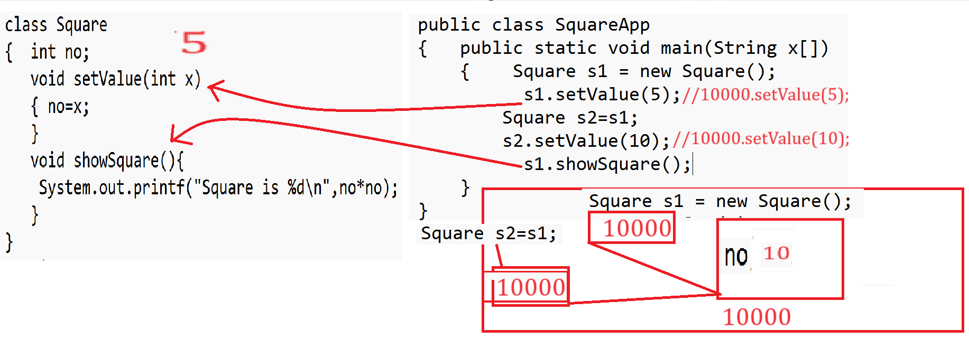
If we think about above diagram we have main method and in main method we have statement Square s1 = new Square() means we have object in my memory whose address is 10000 and we store 10000 in reference variable s1 and we have statement s1.setValue(5) means we store 5 in object whose address is 10000 and again we have statement Square s2=s1; means we store s1 address in s2 means s2 is also one more reference which contain 10000 address so s1 and s2 pointing to same memory location or same object and again we have statement s2.setValue(10) means we store 10 in location 10000 so we override 10 on 5 which is present in 10000 location so last value no=10 so we get answer Square is 100
So we can say if we use more than one reference with single object and if we try to change object by using any one reference then object previous content may be lost and if we want to solve this problem java suggest us use the object clone concept.

How to pass parameter to class function
______________________________________________
If we want to pass parameter to class function, we required to store the local variable of function in instance variable or class variable or static variable
Example: WAP to create class name as Cube with two functions
void setValue(int x)
void showCube()

Example with source code
class Cube
{ int no;
void setValue(int x)
{ no=x;
}
void showCube()
{ System.out.printf("Cube is %d\n",x*x*x);
}
}
public class CubeApp
{ public static void main(String x[])
{ Cube c= new Cube();
c.setValue(10);
c.showCube();
}
}
Output
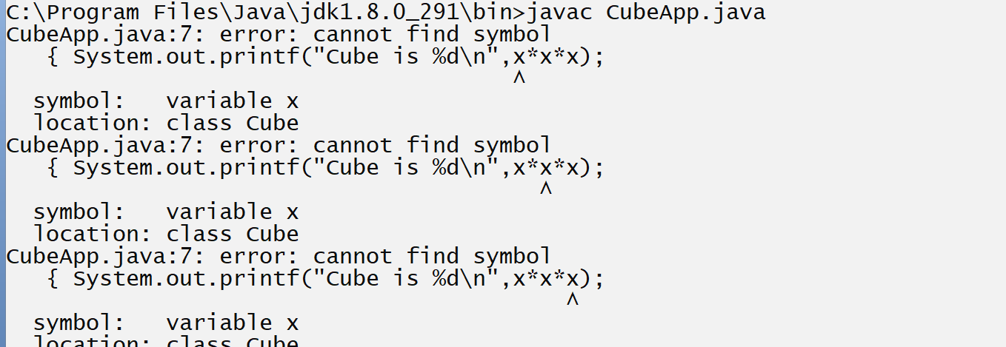
if we think about above code we get compile time error because we try to access local variable x from setValue() function in to showCube() function but we cannot access any function local variable in to another function directly within class and for that we have copy the value of local variable in instance variable because instance variable of class is accessible in all function of class
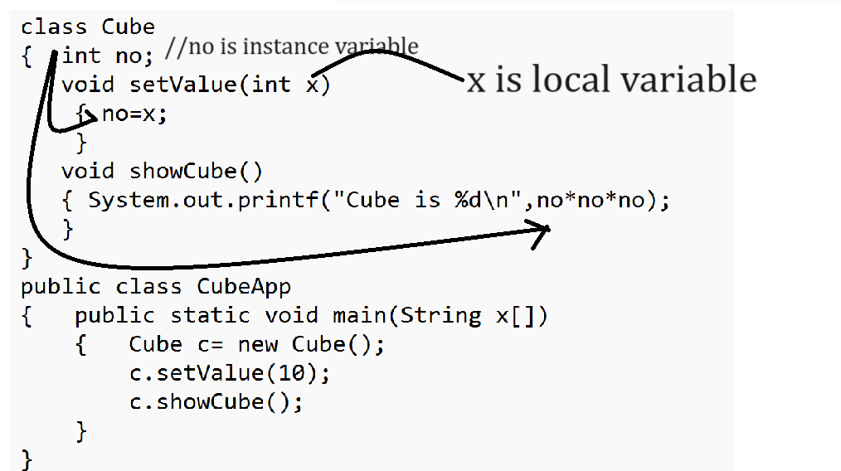
How to pass array as parameter to class function
____________________________________________
If we want to pass array as parameter to class function or any function, we need to pass its base address or reference as parameter to function.
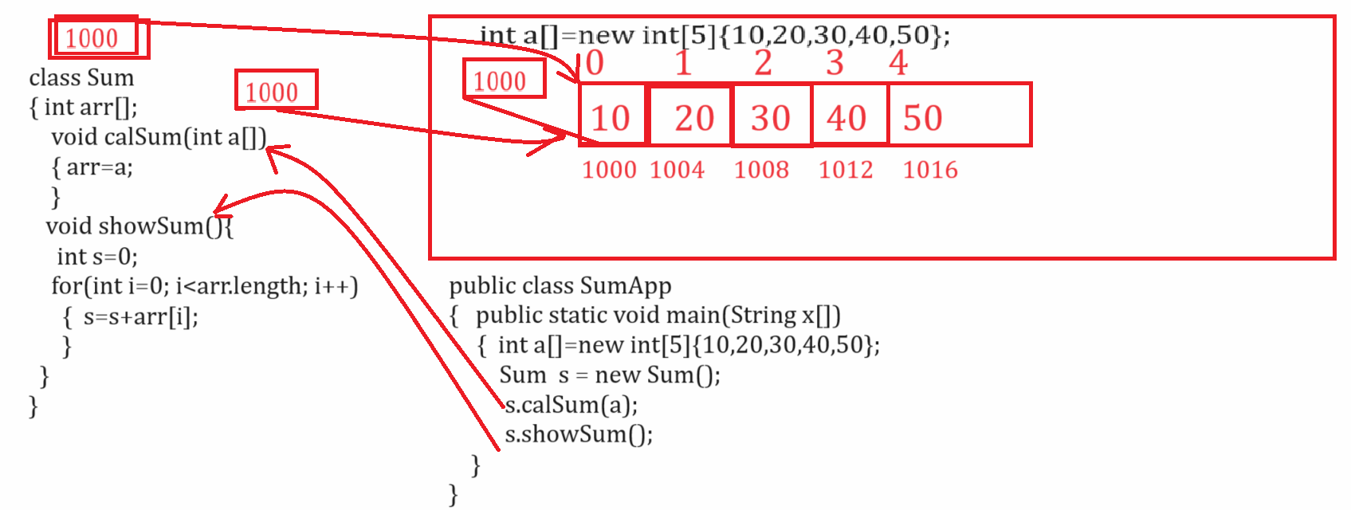
Example with source code
class Sum
{ int arr[];
void calSum(int a[])
{ arr=a;
}
void showSum()
{ int s=0;
for(int i=0; i<arr.length; i++)
{ s=s+arr[i];
}
System.out.printf("Sum is %d\n",s);
}
}
public class SumApp
{
public static void main(String x[])
{ int a[]=new int[]{10,20,30,40,50};
Sum s = new Sum();
s.calSum(a);
s.showSum();
}
}
Assignments
__________________________________________________
Q1. WAP to create class name as SwapDigit with two functions
void setValue(int no): this function can accept number as parameter
int getNumAfterSwap(): this function can swap first and last digit of number and return it.

Q2. WAP to create class name as MergeArray with two functions
void acceptArray(int a[],int b[]): this function accept two array as parameter and merge them and store in third array
void showArray(): this function can show the merged array

Q3. WAP to create class name as ExtractDigitAndSum with two functions
void setValue(char[]): this function can accept character array as parameter
int getSum(): this function can extract digit from number and calculate its sum and return it.
Example: abc123mno45
Output: 1+2+3+4+5 = 15
Q4. WAP to create class name as FindUnion with functions
void setArray(int a[],int b[]): this function accept two array as parameter
void findUnion(): this function can find the union of two array and store in third array
Example: we want to create class name as FindDigit with two functions
void setCharArray(char []): this function can accept character array as parameter
void showDigits(): this function can extract digit from character array and display it.
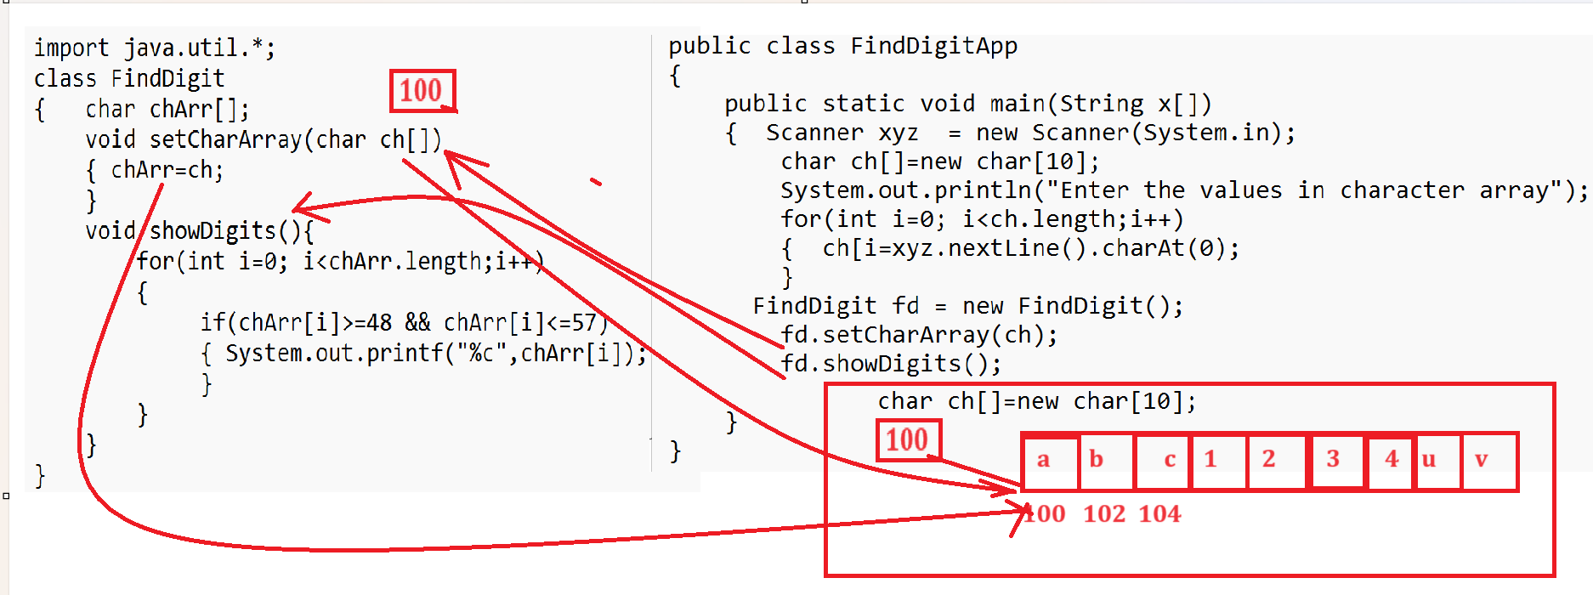
Method with variable arguments
_________________________________________________
Method with variable arguments is facility in Java where we can pass infinite parameter to function as per the user requirements.
Syntax:
return type functionname(datatype …variablename)
{ write here your logics
}
Here … indicate we can pass infinite number of parameter, and it is dynamic array.
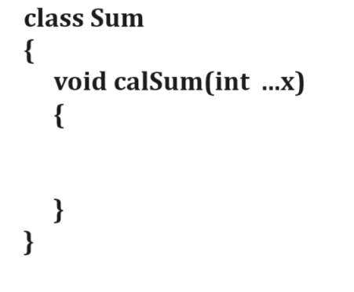
Note: if we think about above screen short we have function name as void calSum(int …x) here … indicate we can pass infinite value of type integer to function name as calSum()
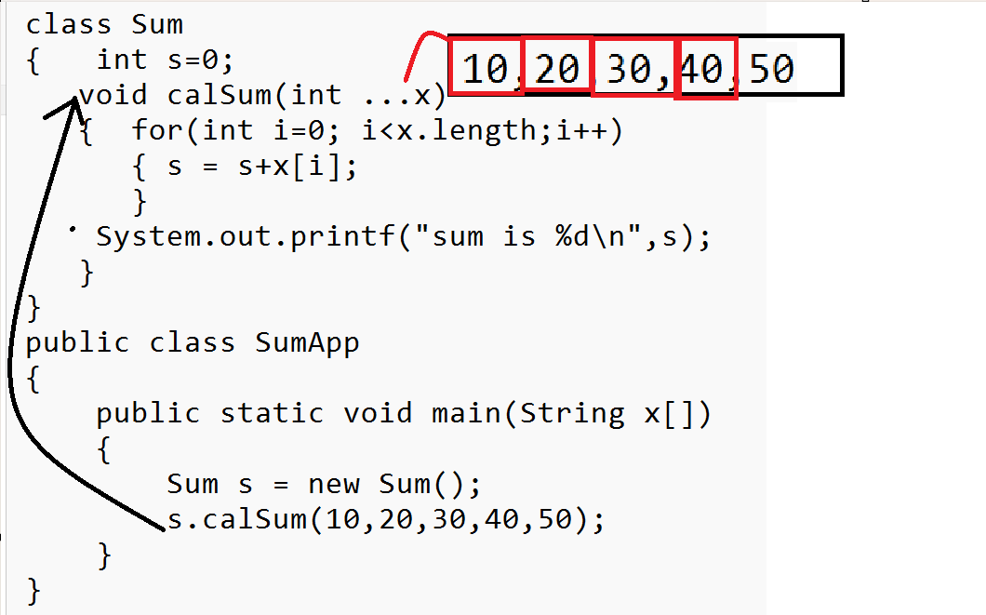
If we want to work with method with variable arguments, we have some important points.
a. …must be left hand side variable and right-hand side of data type.
b. cannot use more than variable argument in single function.
c. if function contain some simple arguments and some variable arguments then variable argument must be last parameter in function.
Example with source code
class Sum
{ int s=0;
void calSum(String name,int ...x)
{ System.out.println("Name is "+name);
for(int i=0; i<x.length;i++)
{ s = s+x[i];
}
System.out.printf("sum is %d\n",s);
}
}
public class SumApp
{
public static void main(String x[])
{
Sum s = new Sum();
s.calSum("ABC",10,20,30,40,50);
}
}
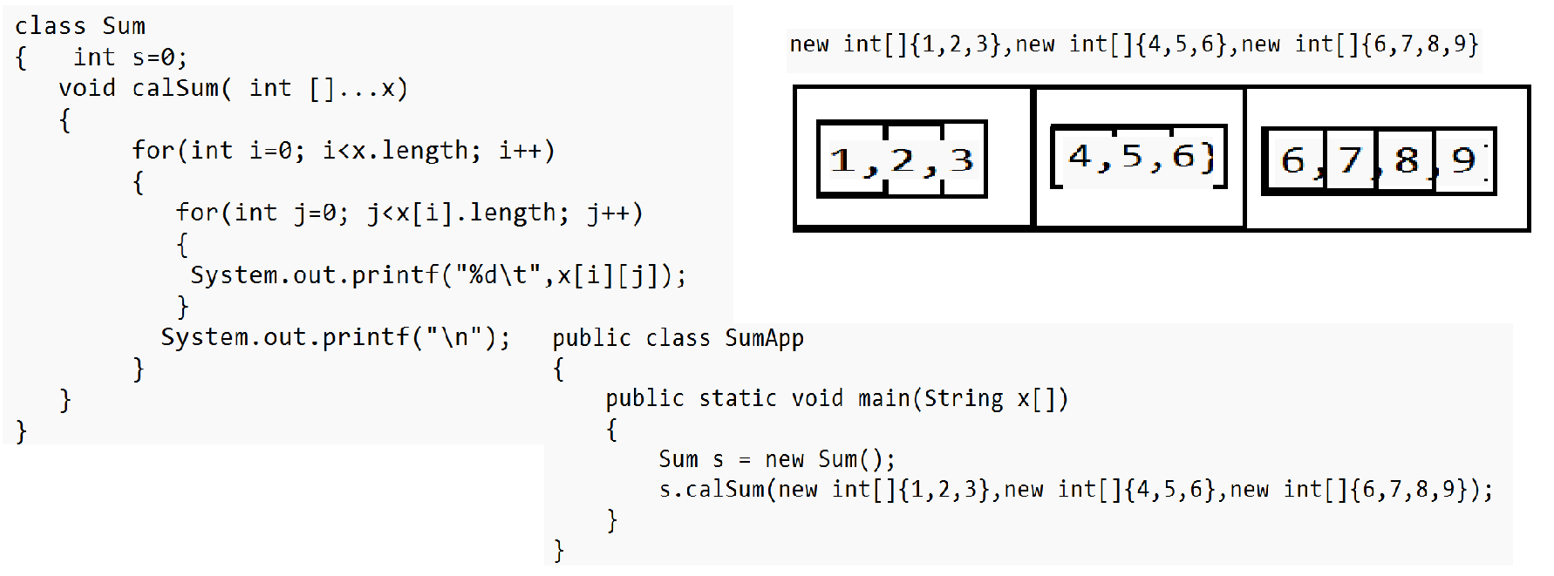

POJO class Concept
_________________________________________________
Q. What is POJO class?
_________________________________________________
POJO stands Plain old java objects so we can say it is concept in which we use setter and getters method, so this type of classes is used for store data or work as container in application and transfer different type of data from one place to another place in application via reference
If we want to write POJO class, you should write set and get keyword with variable name for writing function
Using setter method, we can store data in object and using getter method we can retrieve data from object.

Example of POJO class
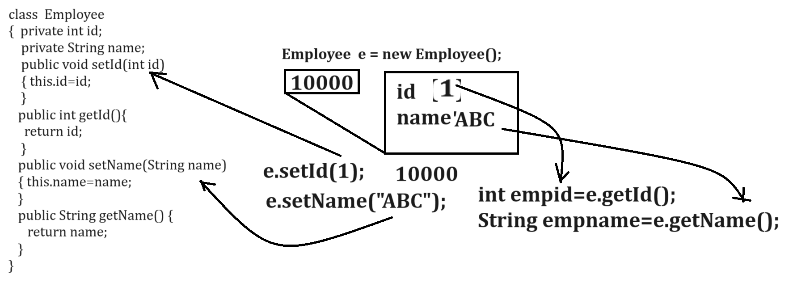

Example with source code
class Employee
{ private int id;
private String name;
public void setId(int id)
{ this.id=id;
}
public int getId(){
return id;
}
public void setName(String name)
{ this.name=name;
}
public String getName(){
return name;
}
}
public class EmployeePOJOAPP
{
public static void main(String x[])
{
Employee e = new Employee();
e.setId(1);
e.setName("ABC");
int empid=e.getId();
String empName=e.getName();
System.out.println(empid+"\t"+empName);
}
}

Example: WAP create POJO class name as Player with field id,name and run and store data in POJO object and display it.

class Player
{
private int id;
private String name;
private int run;
public void setId(int id)
{ this.id=id;
}
public int getId(){
return id;
}
public void setName(String name)
{ this.name=name;
}
public String getName(){
return name;
}
public void setRun(int run)
{ this.run=run;
}
public int getRun(){
return run;
}
}
public class PlayerPOJOAPP
{
public static void main(String ...x)
{
Player p = new Player();
p.setId(1);
p.setName("ABC");
p.setRun(10000);
System.out.println(p.getId()+"\t"+p.getName()+"\t"+p.getRun());
}
}
Q. Why use POJO class and what is benefit of POJO class?
__________________________________________________
The benefit of POJO class to pass different type of data to function
Means when we want to send the different type of data to a function then passing single single parameter is not good approach so better way you can store all data in POJO class object and Pass POJO object as parameter

Shown in following code.
Suppose consider we have class name as Company with two functions
void addNewEmployee(String name,int id,int sal,String address)
void showEmployee()
class Company
{ private String name;
private int id;
private String address;
private int sal;
void addNewEmployee(String name,int id,int sal,String address)
{ this.name=name;
this.id=id;
this.sal=sal;
this.address=address;
}
void showEmployee()
{ System.out.println(name+"\t"+id+"\t"+sal+"\t"+address);
}
}
public class EmployeeApplication
{
public static void main(String x[])
{
Company c = new Company();
c.addNewEmployee("RAM",1,10000,"PUNE");
c.showEmployee();
}
}
Note: if we think about above code we have function name as addNewEmployee() which contain four types of data so when we call this function then we required to know every parameter ,its sequence but we have larger number of parameter then it is very complicated task so better way you can create POJO class and store all parameters in POJO class and pass POJO reference as parameter so we can pass all parameters.
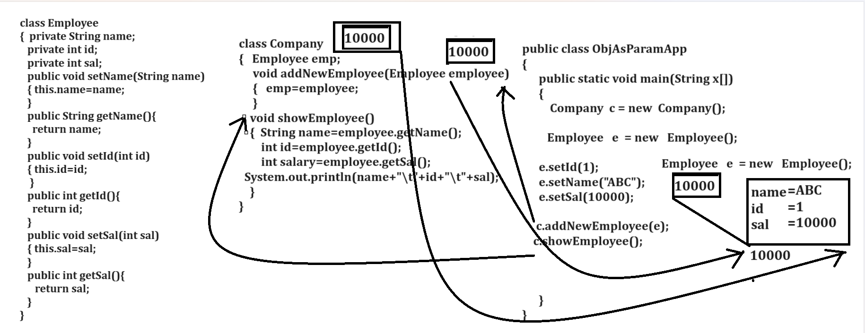

Example with source code
class Employee
{ private int id;
private String name;
private int sal;

public void setId(int id)
{ this.id=id;
}
public int getId(){
return id;
}
public void setName(String name)
{ this.name=name;
}
public String getName(){
return name;
}
public void setSal(int sal)
{ this.sal=sal;
}
public int getSal(){
return sal;
}
}
class Company
{ private Employee emp;
void addNewEmployee(Employee employee)
{ emp=employee;
}
void showEmployee()
{ System.out.println(emp.getName()+"\t"+emp.getId()+"\t"+emp.getSal());
}
}
public class CompanyApplication
{
public static void main(String x[])
{
Company c = new Company();
Employee e = new Employee();
e.setId(1);
e.setName("ABC");
e.setSal(10000);
c.addNewEmployee(e);
c.showEmployee();
}
}
Example: WAP to Create class name as Book with field id, name and price with setter and getter method and create one class name as Library with two methods
void addNewBook(Book b): this function can accept book as parameter
void showBook(): this function can access the book detail and display it.
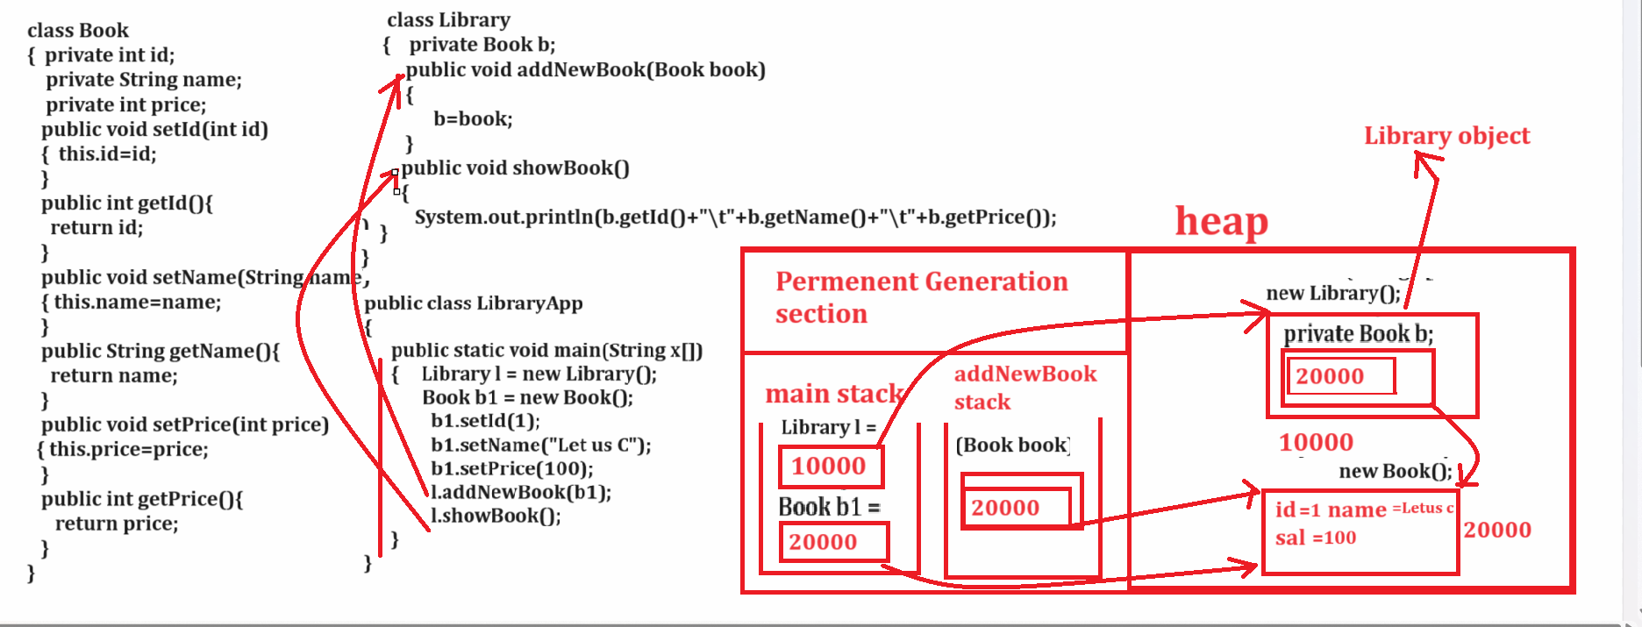

How to set the path of JDK\bin in environmental variable
If we want to set path of jdk\bin in environmental variable we have following steps.

start --- view advanced system setting ---- click on environmental variable --- system variable --- select path variable ---- click on edit button ---- click on new button -- copy path of jdk\bin folder where we installed --- click on ok and finish.

Note: once we set path and if we want to check path is set or not then open the command prompt and go where java file save and type the command javac and if we get following screen then consider your path is set successfully.
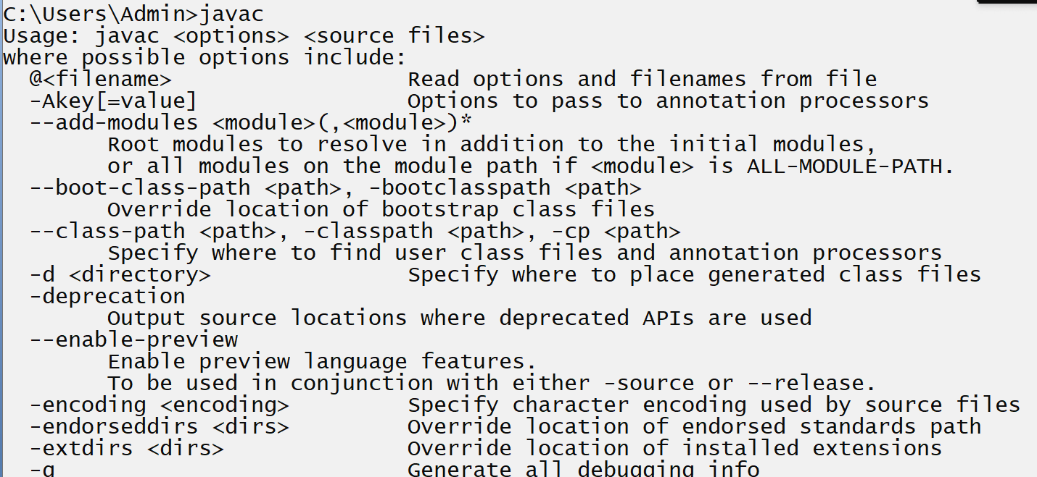
Example
Book.java
public class Book
{
private int id;
private String name;
private int price;

public void setId(int id)
{ this.id=id;
}
public int getId(){
return id;
}
public void setName(String name)
{ this.name=name;
}
public String getName(){
return name;
}
public void setPrice(int price)
{ this.price=price;
}
public int getPrice(){
return price;
}
}
Library.java
public class Library
{ private Book b1;
public void addNewBook(Book book)
{ b1=book;
}
public void showBook()
{
System.out.println(b1.getId()+"\t"+b1.getName()+"\t"+b1.getPrice());
}
}
BookLibApp.java
public class BookLibApp
{
public static void main(String x[])
{
Library l = new Library();
Book b = new Book();
b.setId(1);
b.setName("Let Us C");
b.setPrice(100);
l.addNewBook(b);
l.showBook();
}
}
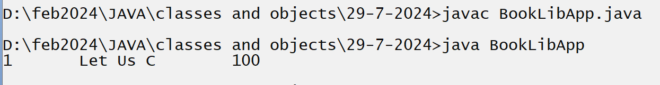

Example: WAP to create class name as Product with field id, name and price with setter and getter methods and we have one more class name as Shop with two methods
void addNewProduct(Product prod)
void showProduct()

Example: WAP to create class FindUnion with two methods
void setArray(int a[],int b[]): this method can accept two array as parameter
int [] getUnionArray(): this method can perform union operation on array and return resultant array

Example: WAP to FindMissingElement with two methods
void setArray(int a[]): this method can accept array as parameter
void showMissing(): this method can find the missing element of array.

Example: WAP to Create class name as Student with field id, name, marks[] with setter and getters means
void setId(int): accept id as parameter
int getId(): return id as parameter
void setName(String name): this method can accept name as parameter
String getName(): return name as parameter
void setMarks(int marks[]): this method can accept marks of six subject
int [] getMarks(): this method can return marks of six subjects
and you have to create one more class name as FindPer with two methods
void setStudent(Student student): this method accept student reference as parameter
void showStudent(): this method can show the student data using reference of student
float getPer(): this method can access six subject marks of student and calculate its percentage and return it.

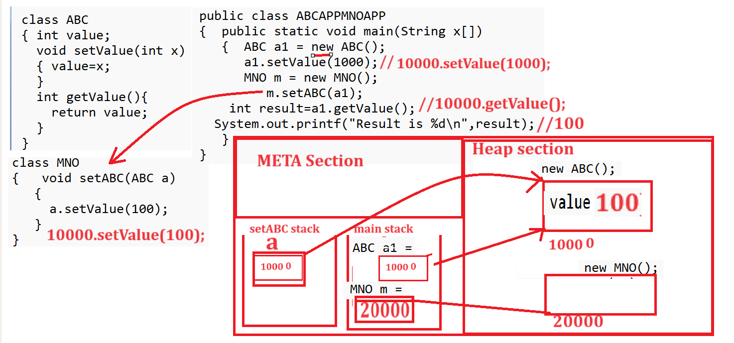

Example with var args with reference
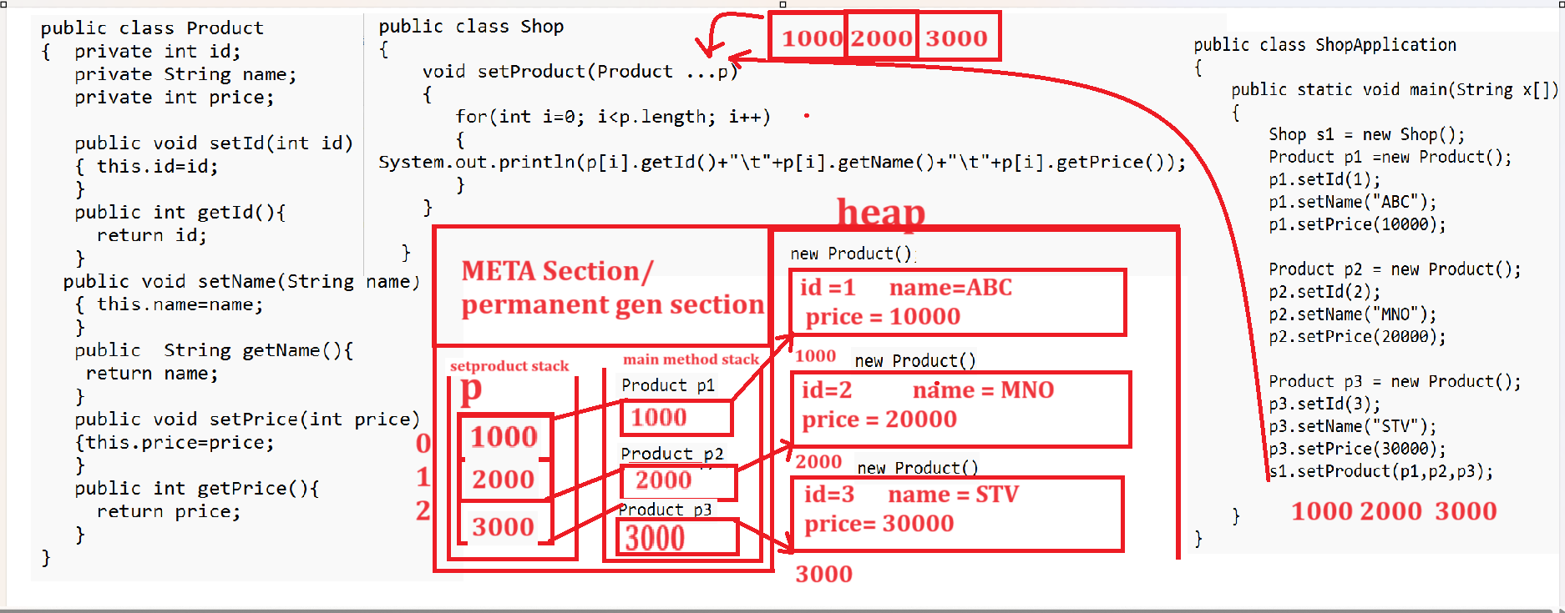

Example with source code
public class Product
{ private int id;
private String name;
private int price;

public void setId(int id)
{ this.id=id;
}
public int getId(){
return id;
}
public void setName(String name)
{ this.name=name;
}
public String getName(){
return name;
}
public void setPrice(int price)
{this.price=price;
}
public int getPrice(){
return price;
}
}
Shop.java
public class Shop
{ Product prod[];
void setProduct(Product ...p)
{
prod=p;
}
Product [] getProducts()
{ prod[1].setId(prod[0].getId()*10+10);
return prod;
}
}
ShopApplication.java
public class ShopApplication
{
public static void main(String x[])
{
Shop s1 = new Shop();
Product p1 =new Product();
p1.setId(1);
p1.setName("ABC");
p1.setPrice(10000);

Product p2 = new Product();
p2.setId(2);
p2.setName("MNO");
p2.setPrice(20000);

Product p3 = new Product();
p3.setId(3);
p3.setName("STV");
p3.setPrice(30000);
s1.setProduct(p1,p2,p3);
Product prods[]=s1.getProducts();
for(int i=0;i<prods.length;i++)
{ System.out.println(prods[i].getId()+"\t"+prods[i].getName()+"\t"+prods[i].getPrice());
}
}
}
Enhance for loop
__________________________________________________
Enhance for loop is introduce in JDK 1.5 version of JAVA
and it is used for fetch data from array or collection
and enhance for loop has not required to provide initialization and conditions as well as not write increment or decrement manually so it is specially design for fetch data from array or collection etc
Syntax: for(datatype variablename:array or collection){
}

Example with source code
public class TestArr
{
public static void main(String x[])
{
int a[]=new int[]{10,20,30,40,50};
for(int val:a)
{ System.out.println(val);
}
}
}

Q. what is difference between enhance for loop and normal for loop?
____________________________________________________
A) Enhance for loop always work in forward direction means cannot work in decremented order or normal loop can work incremental order as well as decremented order
B) Enhance for loop always increment by 1 so normal for loop can increment by more than 1
c) If we use enhance for, we not required using index for fetch data from array but if we use normal for loop we required to use index for fetch data from array.

Assignments
________________________________________________
Example: WAP to create billing application you have to design the following classes
Create class name as Product with field id, name and price,qty and mark this class as POJO class.
and create one class name as Shop with two methods
void setProducts(Customer c,Product …p): this method can accept infinite products
Customer POJO class with field id,name and address ,contact
void calBill(): this method can calculate bill and your bill format like as
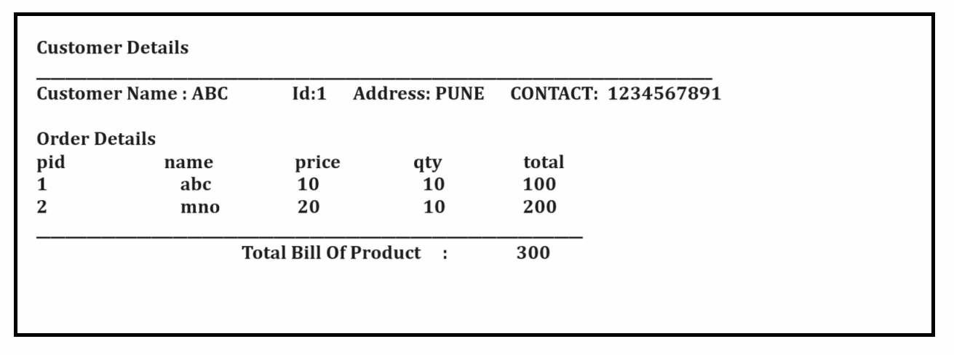

Example: WAP to develop application for voting booth.
you have to create classes name as
1. Ward with field wardId,wardName,Voter and Ward is POJO class so it contain
void setWardId(int wardId)
int getWardId()
void setWardName(String name)
String getWardName()
void setVoter(Voter …voter)
Voter [] getVoter();

Here you have to create POJO class name as Voter with field
id, name, age and you have to create one more class name as
VotingMachine with following methods

void steWards(Ward …w): this method can more than one wards
void showVotingCount(): this method can show the voting ward wide and consider voter whose age is greater than 18.

VotingMachingApplication contain main method
Output Like as
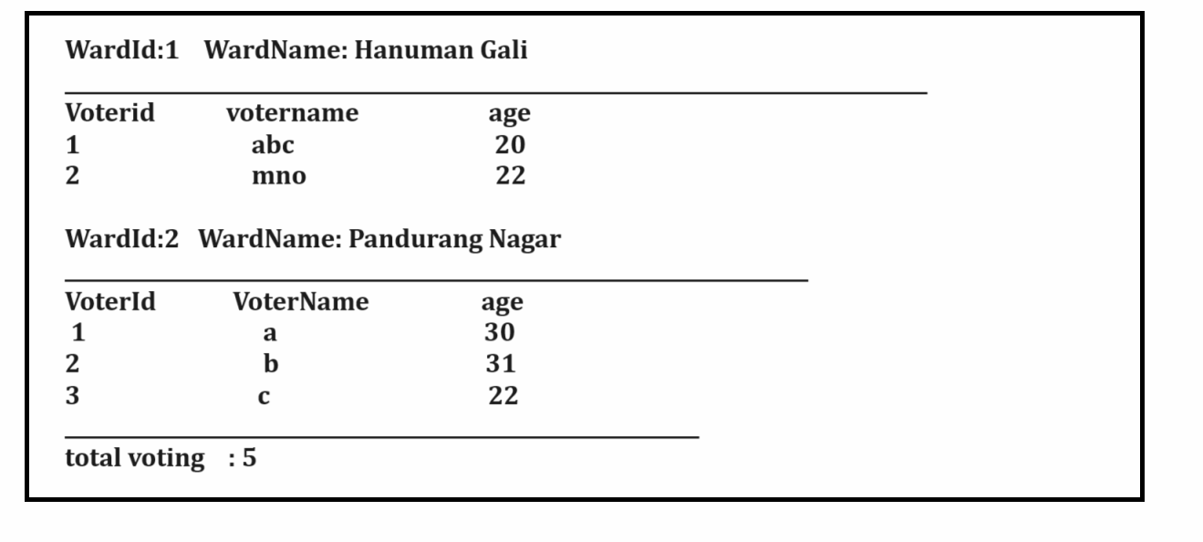

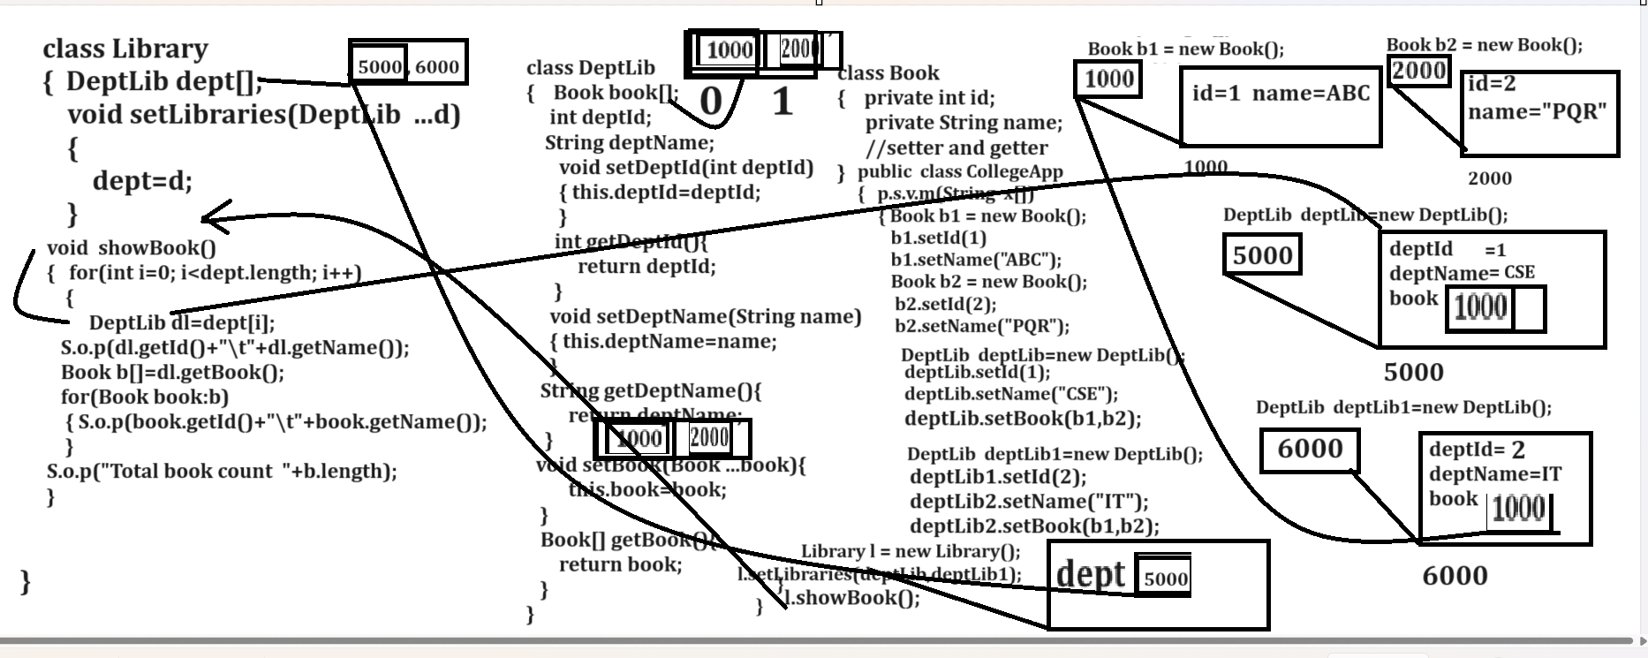

Book.java
class Book
{
private int id;
private String name;

public void setId(int id)
{ this.id=id;
}
public int getId(){
return id;
}
public void setName(String name)
{ this.name=name;
}
public String getName(){
return name;
}
}
DeptLib.java
class DeptLib
{
private int id;
private String name;
private Book book[];

public void setId(int id)
{ this.id=id;
}
public int getId(){
return id;
}
public void setName(String name)
{ this.name=name;
}
public String getName(){
return name;
}
public void setBooks(Book ...b)
{
this.book=b;
}
public Book [] getBooks(){
return book;
}
}
Library.java
class Library
{
private DeptLib dept[];

void setLibraries(DeptLib ...d)
{ dept=d;
}
void showDetails()
{
for(int i=0; i<dept.length;i++)
{
DeptLib dl =dept[i];
System.out.println("ID\tNAME");
System.out.println(dl.getId()+"\t"+dl.getName());
Book b[]=dl.getBooks();
System.out.println("===============================");
for(Book book:b)
{ System.out.println(book.getId()+"\t"+book.getName());
}
System.out.println("total book count is "+b.length);
System.out.println("============================");
}
}
}
College.java
public class College
{
public static void main(String x[])
{
Book b1 = new Book();
b1.setId(1);
b1.setName("JAVA");
Book b2 = new Book();
b2.setId(2);
b2.setName("Python");

DeptLib deptLib1 = new DeptLib();
deptLib1.setId(1);
deptLib1.setName("CSE");
deptLib1.setBooks(b1,b2);
Book b3 = new Book();
b3.setId(1);
b3.setName("MERN");
Book b4 = new Book();
b4.setId(2);
b4.setName("SQL");

DeptLib deptLib2 = new DeptLib();
deptLib2.setId(2);
deptLib2.setName("IT");

deptLib2.setBooks(b3,b4);

Library l = new Library();
l.setLibraries(deptLib1,deptLib2);
l.showDetails();
}
}

static keyword
_____________________________________________
static keyword can use with variable, with function and with nested class.

static variable, instance variable
___________________________________________________
a. static variable known as class level variables and instance variable known as instance level variables or object level variable means if we think about static variable then static variable allocate memory before creating object of class and instance variable can allocate memory after creating object of class
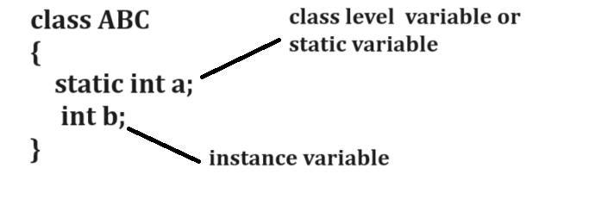

b. static variable can allocate memory before creating object in permanent generation section of memory or meta section of memory and instance variable can allocate memory after creating object of class means instance variable present in object so we cannot use instance variable without using object but we can use static variable by using classname.membername
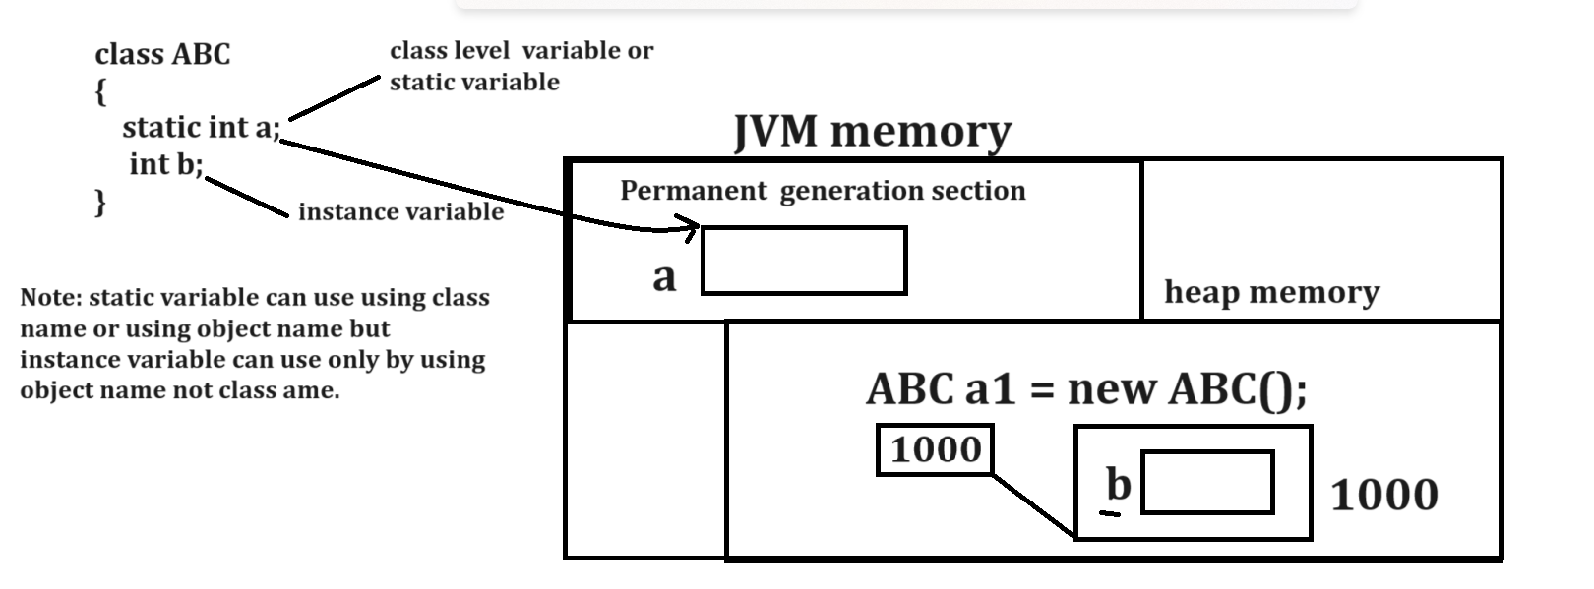
Example with source code
class ABC
{ static int a=100;
int b=200;
}
public class ABCSTATAPP
{
public static void main(String x[])
{
System.out.println("A is "+ABC.a);
ABC a1 = new ABC();
System.out.println("B is "+a1.b);
System.out.println(“A is using object “+a1.a);
}
}
c. static variable can share its common copy between more than one object of same class, but instance variable can share its separate copy with every object.
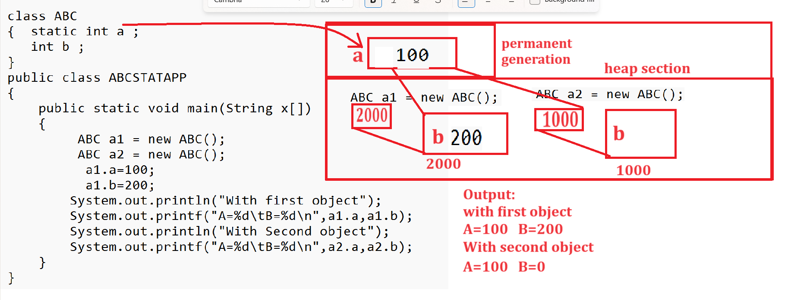

d. static variable life present whenever application or program running in memory but instance variable life present when ever object running in memory.
Note: if we want to calculate the life of instance variable before that we should have to know the life of object.

Q. Whenever object present in memory?
object present in memory whenever object use by any one reference when object not use by any reference then JVM automatically delete the memory of object called as garbage collection.

Q. What is garbage collection?
Garbage collection is automatic memory management technique of JVM which release the memory of object automatically when it is not use in future.
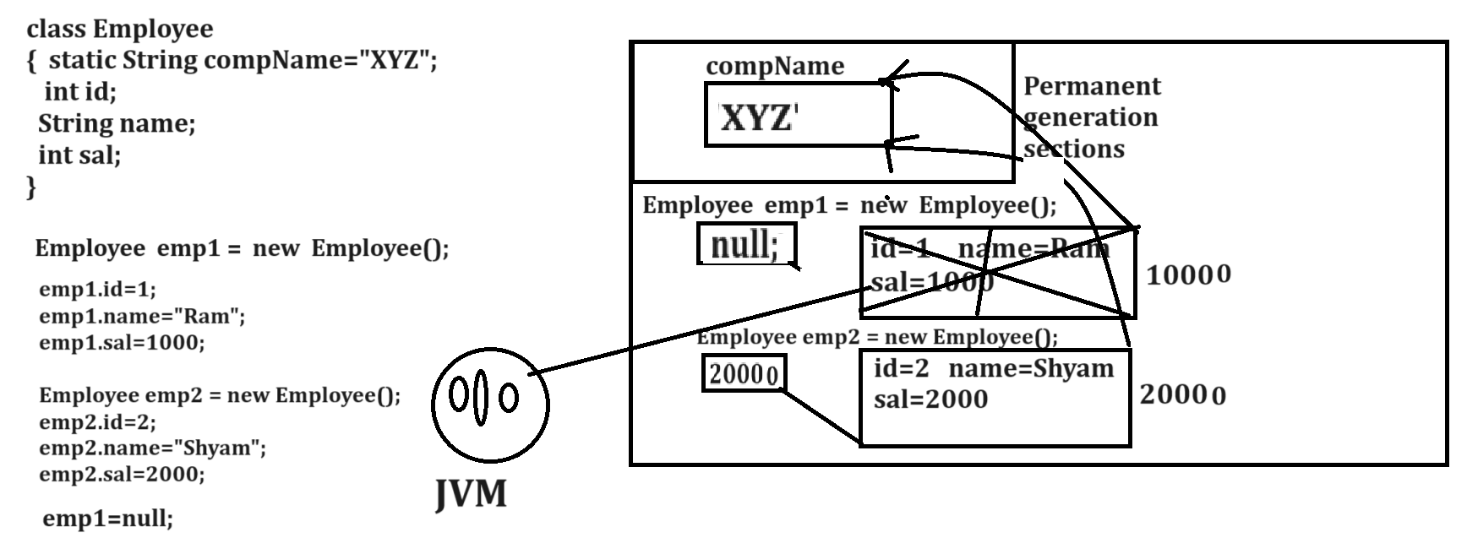

e. static variable and instance variable has default value as per their data type.
Data Type | Default value
int | 0
Float | 0.0f
Double | 0.0
Long | 0
Short | 0
Byte | 0
Boolean | False
String | Null
Char | blank

Local variables
___________________________________________________
Local variable means variable declared within function called as local variable.
If we want to work with local variable we have some important points.
1. Local variable cannot access outside of his block or function
Example with source code
class TestLocal{
void setValue(int x) {
}
void showSquare()
{ System.out.printf("Square is %d\n",x*x);
}
}
public class TestLocalApp
{ public static void main(String x[])
{ TestLocal tl = new TestLocal();
tl.setValue(10);
tl.showSquare();
}
}

Output
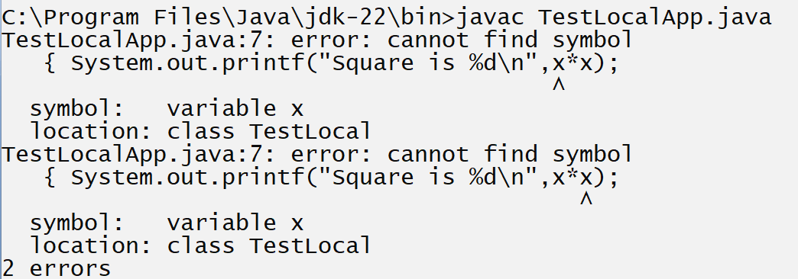
If we think about above code we get compile time error because we have variable x we declare within void setValue(int x) and we try to access that variable outside function i.e in showSquare() and we cannot access local variable outside of his block so we get compile time error.
Note: if we want to use the value of local variable outside of his block then we need to copy the value of local variable in instance variable so the benefit we can access instance variable of class in all functions shown in following code.
Example with source code
class TestLocal
{ int m;
void setValue(int x)
{ m=x;
}
void showSquare()
{ System.out.printf("Square is %d\n",m*m);
}
}
public class TestLocalApp
{ public static void main(String x[])
{ TestLocal tl = new TestLocal();
tl.setValue(10);
tl.showSquare();
}
}
2. Local variable cannot have default value even garbage also so if we want to use local variable before that we must be initialize some value in it.
Example with source code
class TestLocal
{ void setVal()
{ int m; //m is local variable
System.out.println(m);
}
}
public class TestLocalApp{
public static void main(String x[])
{ TestLocal tl = new TestLocal();
tl.setVal();
}
}

Output
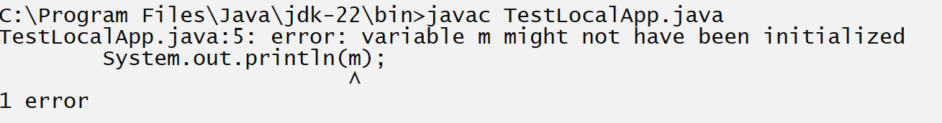
If we think about above code we get compile time error because we have local variable int m; we not initialize any value in it and we try to use local variable but in java if we want to use any variable it must have some value but local variable cannot have any value so we cannot use it so compiler generate error to us if we want to solve this problem we required to initialize some value in local variable m and after that we can use it.
Example with source code
class TestLocal
{ void setVal()
{ int m=10; //m is local variable
System.out.println(m);
}
}
public class TestLocalApp
{ public static void main(String x[])
{ TestLocal tl = new TestLocal();
tl.setVal();
}
}
Output
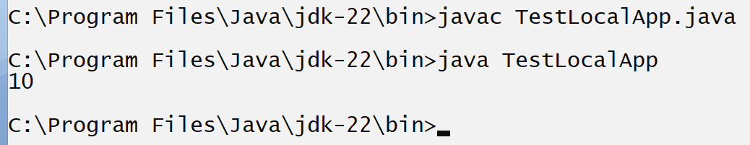

3. we cannot declare local variable as static and if we try to declare it as static then compiler will generate compile time error to us.
Example with source code
class TestLocal
{
void setVal()
{ static int m=10; //m is local variable
System.out.println(m);
}

}
public class TestLocalApp
{ public static void main(String x[])
{ TestLocal tl = new TestLocal();
tl.setVal();
}
}
Output
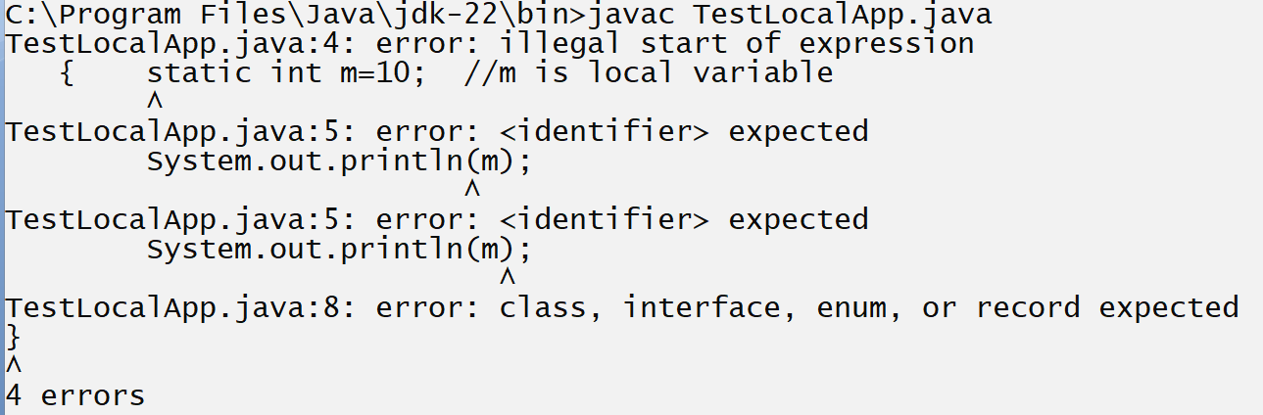

Q. why we cannot declare local variable as static?
_____________________________________________________________
There are two reasons
1. Life: if we think about local variable then life of local variable present within block means when block ends then local variable get destroy but if we think about static variable then life of static variable is present whenever program running in memory.
2. Memory allocation area: if we think about static variable then memory of static variable gets allocated before creating object of class in META section or permanent generation section of memory and if we think local variable its memory get allocated in stack and memory allocate after function calling point.

4. If we have same name instance variable and same name local variable then instance variable cannot in local block where local variable name is same
Example with source code
class TestLocal
{ int m; //instance variable
void setVal(int m) //local variable
{ m=m;
}
void showSquare()
{System.out.println("Square is "+(m*m));
}
}
public class TestLocalApp
{ public static void main(String x[])
{ TestLocal tl = new TestLocal();
tl.setVal(5);
tl.showSquare();
}
}
Note: if we think about above code, we get result Square is 0 because we have same name instance variable and same name local variable.
So, if we want to solve this problem we can use this reference show in following code
Example with source code
class TestLocal
{ int m; //instance variable
void setVal(int m) //local variable
{ this.m=m;
}
void showSquare()
{System.out.println("Square is "+(m*m));
}
}
public class TestLocalApp
{ public static void main(String x[])
{ TestLocal tl = new TestLocal();
tl.setVal(5);
tl.showSquare();
}
}
Output
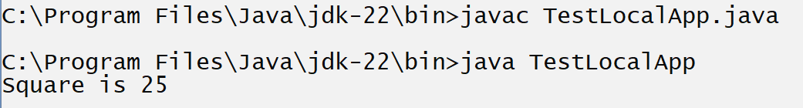

Q. what is this reference?
________________________________________________________
this is internal reference present in every class which is used for point to current running object in memory.
How can we identify current running object or working object in memory?
___________________________________________________________
Function calling object known as working object shown in following diagram
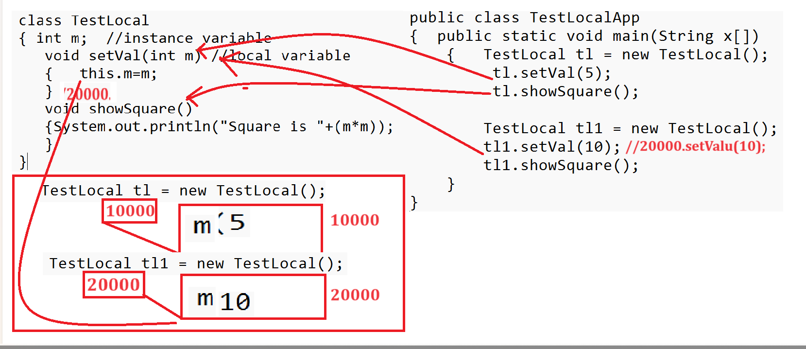

5. We cannot apply any access specifier on local variable like as private, protected, public or default
Example with source code
class TestLocal
{ int m; //instance variable
void setVal(protected int m) //local variable
{ this.m=m;
}
void showSquare()
{System.out.println("Square is "+(m*m));
}
}
public class TestLocalApp
{ public static void main(String x[])
{ TestLocal tl = new TestLocal();
tl.setVal(5);
tl.showSquare();

TestLocal tl1 = new TestLocal();
tl1.setVal(10);
tl1.showSquare();
}
}
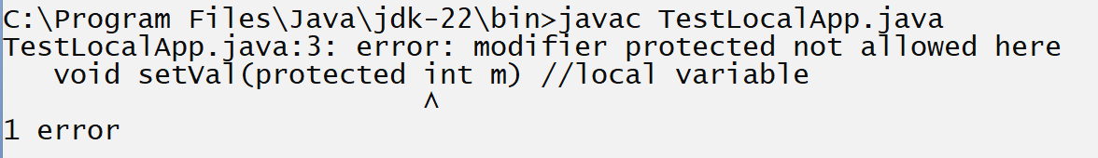

Array of objects
________________________________________________________________
Array of objects is used for store more than one object data in single name reference called as array of objects.
Example: suppose we have Employee class, and we want to create five object of employee class and store data in it and display it. so here we required to create 5 different employee objects so creating 5 different separate object is not good approach better way you can create array of objects
How to Create Array of objects
_________________________________________________________________
Syntax: classname ref[] = new classname[size];//array of reference
for(int i=0; i<ref.length; i++) {
ref [i] = new classname();
}
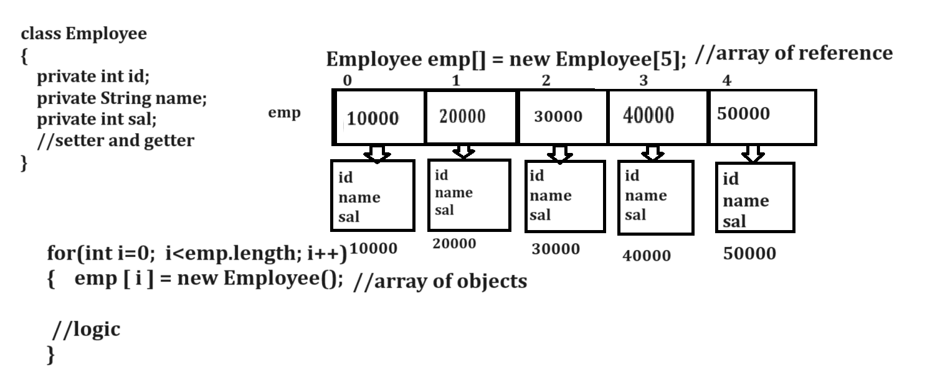
Above diagram demonstrate the array of objects memory
Example with source code.
import java.util.*;
class Employee
{ private int id;
private String name;
private int sal;
public void setId(int id)
{ this.id=id;
}
public int getId(){
return id;
}
public void setName(String name)
{ this.name=name;
}
public String getName(){
return name;
}
public void setSal(int sal)
{ this.sal=sal;
}
public int getSal(){
return sal;
}
}
public class EmployeeApp
{
public static void main(String x[])
{
Employee emp[]=new Employee[5];//array of reference
for(int i=0;i<emp.length;i++)
{ Scanner xyz = new Scanner(System.in);
emp[i]=new Employee();//array of objects
System.out.println("Enter name id and salary");
String name=xyz.nextLine();
int id=xyz.nextInt();
int sal=xyz.nextInt();
emp[i].setId(id);
emp[i].setName(name);
emp[i].setSal(sal);
}
System.out.println("display all employee data");
for(int i=0;i<emp.length;i++)
{
System.out.println(emp[i].getId()+"\t"+emp[i].getName()+"\t"+emp[i].getSal());
}
}
}
Assignments
_______________________________________________________________
Q1. WAP to create POJO class name as Book with field id, name and price and create 5 objects of book class using array of objects and arrange all books in descending order by using its price.
Q2. WAP to create POJO class name as Student with field id, name and per and create array of object student with size 5 and input the id of student and search student record in student object array and if student then display student found otherwise display message student not found.

Q3. WAP to Create class name as Product as POJO with field id, name and price create array of object of product of size 10 and find the product whose price is same.
Nested classes
_____________________________________________________________
Nested classes means class within class called as nested class
Q. Why we need to declare nested classes?
_____________________________________________________________
We cannot use private, static and protected access specifier with class directly and if we want to declare it as private or static or protected then we required declaring class as nested class
Example class with private access specifier
private class T {
}
public class NestedApp
{ public static void main(String x[])
{ T t1 =new T();
}
}
Note: if we think about above code we get compile time error.
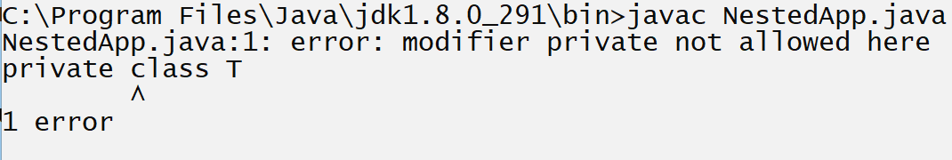

Q. Why we cannot declare outer class as private?
If we declare any outer class as private, then we cannot create its object as well as cannot inherit the class in another class and if we want to use any class then we have only two ways 1. Using object 2. Using inheritance but private not support these two approaches means private class is useless class so not declare class as private.
Example outer class with protected access specifier
protected class T{
}
public class NestedApp
{ public static void main(String x[])
{ T t1 =new T();
}
}
Output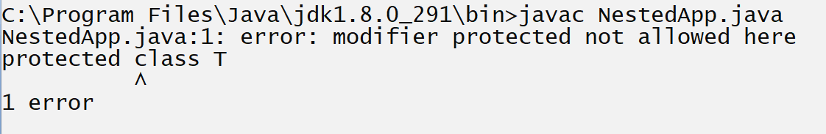

Q. Why outer class not declare as protected?
Protected class also cannot create its object and if we try to inherit the protected class and if class contain public member, then public member cannot inherit in child class if we inherited class as protected so avoiding this problem class cannot declare as protected.
Example outer class with static keyword
static class T
{
}
public class NestedApp
{ public static void main(String x[])
{ T t1 =new T();
}
}
Output
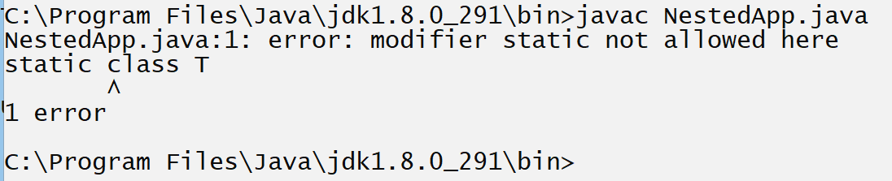

Q. Why we cannot declare class as static?
Because static member can allocate memory before creating object of class and class cannot allocate memory without object so we cannot declare class as static.
Note: we can declare nested class as private, protected or static.
Example of nested classes
class TA{
protected class T {
}
}
public class NestedApp
{ public static void main(String x[]) {
}
}
or
class TA{
static class T{
}
}
public class NestedApp
{ public static void main(String x[]) {
}
}
or
class TA{
private class T{
}
}
public class NestedApp
{ public static void main(String x[]) {
}
}
Note: if we declare class as inner class then inner class is member of outer class and outer class can apply restrictions on its member i.e. on inner class means can mark as private, protected or static etc.

There are four types of nested classes in JAVA
_____________________________________________________________
a. Simple Nested class: Simple Nested class means if we declare one class directly within another class called as simple nested class.
Example with source code
class ABC
{ void display()
{ System.out.println("I am Member of ABC");
}
class MNO
{ void show()
{ System.out.println("I am member of MNO");
}
}
}
How to create object of simple nested class?
Syntax:
Outerclassname.innerclassname ref=new outerclassname().new innerclassname();
Example: ABC.MNO m = new ABC().new MNO();
Note: here m is reference of MNO class means using m we can access only member of MNO not ABC
or
Syntax:
Outerclassname oref = new Outerclassname();
Outerclassname.innerclassname iref=oref.new innerclassname();
Example:
ABC a = new ABC();
ABC.MNO m =a.new MNO();
Example with source code
class ABC
{ void display()
{ System.out.println("I am Member of ABC");
}
class MNO
{ void show()
{ System.out.println("I am member of MNO");
}
}
}
public class SimpleNestedApp
{ public static void main(String x[])
{ ABC a = new ABC();
a.display();
ABC.MNO m=a.new MNO();
m.show();
}
}

b. Local Nested class: Local Nested class means if we declare class within function of outer class called as local nested class.
class ABC
{
void display()
{
class MNO
{
void show()
{ System.out.println("I am show");
}
}
MNO m=new MNO();
m.show();
}
}
public class LocalNestedApp
{ public static void main(String x[])
{
ABC a1 = new ABC();
a1.display();
}
}
C. static Nested class: static nested class means if we declare nested class with static keyword called as static nested class.
class ABC
{
static class MNO
{
void show()
{ System.out.println("I am static nested class");
}
}
}
How to create object of static nested class
Syntax:
outerclassname.innerclassname ref=new outerclassname.innerclassname();
Example: ABC.MNO m=new ABC.MNO();
class ABC{
static class MNO {
void show()
{ System.out.println("I am static nested class");
}
}
}
public class LocalNestedApp
{ public static void main(String x[])
{ ABC.MNO m=new ABC.MNO();
m.show();
}
}
d. Anonymous inner class or Anonymous nested class
Note: we will discuss this concept in inheritance chapter at the time of abstract class or interface.

3. Provide encapsulation
Q. What is encapsulation?
______________________________________________________________
Encapsulation means to hide the implementation detail from end user at implementation level called as encapsulation means if we want to achieve encapsulation, we can declare class variable as private and access it via public function called as encapsulation and the major goal of encapsulation is data security
Example of encapsulation
class Employee
{ private int id;
private String name;
private int sal;
public void setId(int id)
{ this.id=id;
}
public int getId(){
return id;
}
public void setName(String name)
{ this.name=name;
}
public String getName()
{ return name;
}
public void setSal(int sal)
{ this.sal=sal;
}
public int getSal(){
return sal;
}
}
Example: If you are working on web application and we want to input username and password from login form and provide access of web app to the user who is already registered
Example: Suppose we are working of billing application, and we want to give the 25% discount on bill only for employee of shop otherwise not.
Example with source code
class Bill
{ private int qty;
private int rate;
private int total;
private String userType;

public void setQty(int qty)
{ this.qty=qty;
}
public int getQty()
{return qty;
}
public void setRate(int rate)
{ this.rate=rate;
}
public int getRate()
{ return rate;
}
public void setUserType(String userType)
{ this.userType=userType;
}
public String getUserType()
{ return userType;
}
public int getTotal()
{ if(userType.equals("employee"))
{ return (qty*rate)-(qty*rate)*25/100;
}
else{
return qty*rate;
}
}
}
public class EncapApp
{ public static void main(String x[])
{ Bill b = new Bill();
b.setQty(10);
b.setRate(100);
b.setUserType("employee");
int total=b.getTotal();
System.out.println("Total is "+total);
}
}

